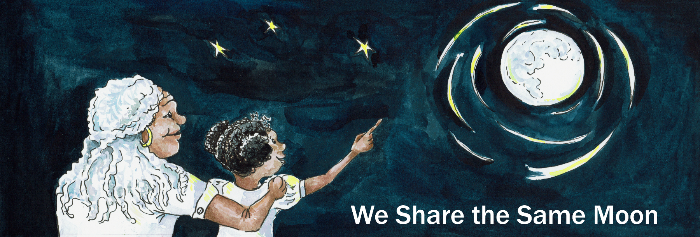
Suggested Age Range: 7 - 8 years; 8 - 9 years; 9 - 10 years; 10 - 11 years; Adult;
UK Curriculum: Key Stage Two (Lower); Key Stage Two (Upper);
Suggested UK Year Groups: Year Three, Year Five
UK Primary Curriculum Links: Light; Earth and Space
Science Subject: The Moon
Science Questions: Why Does the Moon change shape?
Suggested Science Activity: Moon Globes; Moon Phases
Children with SEND: Use to boost comprehension of science vocabulary
EAL children: For intermediate learners
Country of Origin: Inuit - First Nations of Canada
Source: Why the Man in the Moon is Happy by Ronald Melzack

Long ago, when the world began, the Moon had only one face, it was always round and full. And the Moon’s mask was carried across the sky, by a young man, who’s face was as round and full and pale as the mask of the Moon that he carried.

And at first, the young man was proud to carry the Moon-mask, to light up the sky at night. But as he carried the mask across the sky, all night, every night, night after night, he grew lonely.

He would look down at the people below, and he could see them gathered around a fire, talking, laughing, drumming, dancing. He wanted so much to join them.
But of course he could not. His job was to carry the Moon across the sky, all night. And every night. Alone.

Sometimes one of the people down below, would glance up at the Moon, and he would feel a glimmer of hope. Some-one had seen him! Perhaps they would say hello! But of course they did not. They never saw the man behind the mask he carried. And so he carried on alone. Carrying the Moon across the sky, all night, every night, night after night.

Until …One night, as he went past a lake, he saw a young woman, sitting away from the fire. And she was looking down at the water as he passed by.
And, as she saw the Moon reflected in the water, she noticed the man carrying the Moon-mask. She was filled with wonder! What must it be like to carry the Moon across the sky?

“Hallo, Man with the Moon!” she said.
The poor man almost dropped the mask in shock! Some-one had seen him! Finally!
He didn’t know what to do. So he said “Hallo”
And as the Moon slid slowly past the lake, the young woman smiled.
The next night, the Man with the Moon, was excited! Would she be there again?
She was! Would she speak to him again? She did! “Hallo, Man with the Moon!
“What a difficult job it must be to carry the weight of the Moon all by yourself!”

And from that night on, she spoke to him, every night.
And the Man with the Moon felt his life begin to change. He had a friend!
And of course as time passed, they became more than friends …

Until …One night, the young woman looked up at him and said:
“I wish I could join you up there in the sky. We could carry the Moon together".
The poor Man with the Moon, nearly dropped it again!
Really? Could this be true? Could this be possible? Could she? Would she?

The next night, the young woman walked to her place by the lake. And looked down in the water and then up in the sky. But there was no Moon! Where was he?
“I am here” said a voice.
And she looked around and behind stood a young man, as pale as the Moon.
“Did you mean it? Would you join me in the sky?” “Yes” she said “I will!”
“But how?” The Man in the Moon asked.
She smiled; “Come back in five nights.” And he did.

And while he was gone, she and her family worked. All day and night, cutting wood, stitching leather and building two tiny tents and filling them with all the things she would need to join the Man with the Moon. And then when he returned, she led him to her camp. She opened the flap of one of the tents and he looked inside and saw:
The tent was filled with moon-masks - of different shapes and sizes!
From a slither, to a feather, to a crescent shape, to a half-moon, through to full.
“These are yours!” she said.
And then she showed him the second tent - which was also full of moon-masks.
A full moon, a half moon, a crescent, a feather and the tiniest of slithers.
“These are mine” she said.
“I will share with you, the task of carrying the Moon across the sky.
And every twenty-eight nights, there will be no Moon - so we can be together.”
And the Man with the Moon smiled.
And it is said, that if you go to the Moon, you will see two tiny tents pitched there, and if you look very carefully, you might just see the Man AND the Woman who live there.
Copyright; Cassandra Wye, May 2019

